This document is best viewed in web-layout

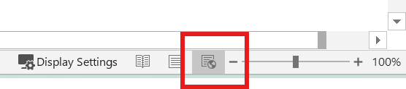

1. Make your headings:

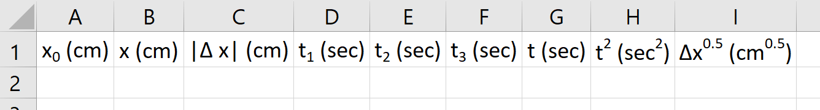

* 1. For the super/subscript portions I recommend typing them in Word, then copy and pasting them into Excel (it’s much less tedious than accessing the same font feature in Excel)

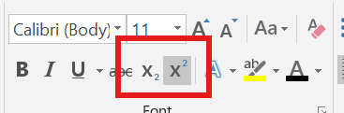

* 1. The ‘|’ character can be typed by holding ‘shift’ and pressing the ‘\’ key above the ‘Enter’ key
  2. The “Δ” character can be found under the “Insert” tab of the ribbon under the symbol menu next to the blue “Ω” logo

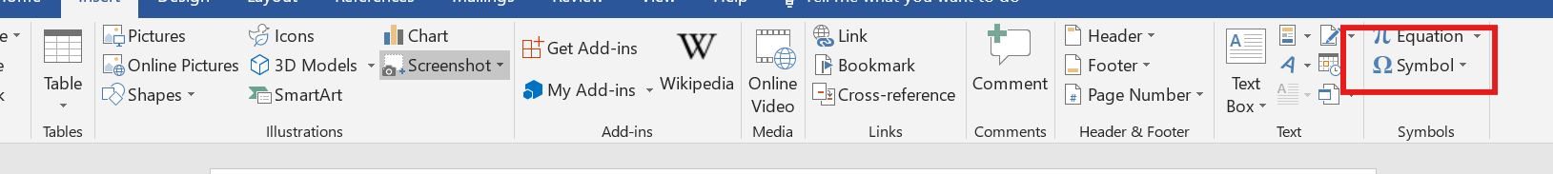

* + 1. If it’s not one of the default symbols click “more symbols” and find “Greek and Coptic” from the 2nd drop down (this menu is not alphabetized)

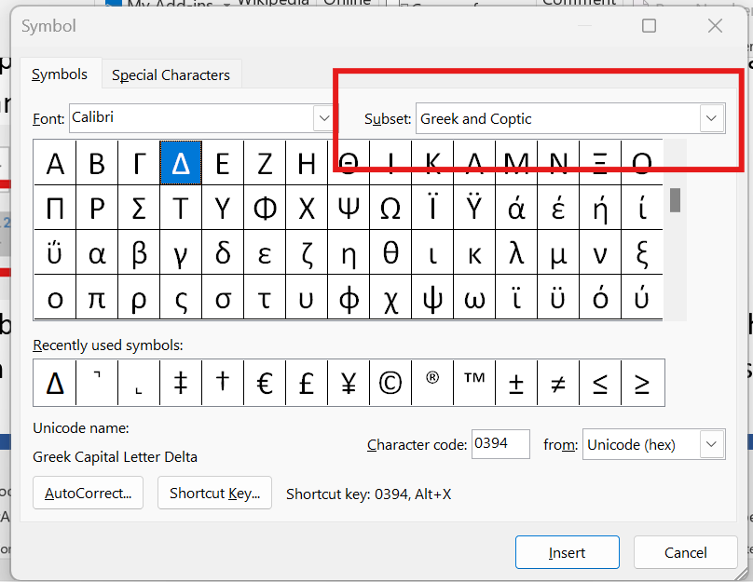

1. Enter the data from the 1st, 2nd and 4th-6th columns of your lab into your excel book.
2. Write the formulae for columns C,G,H & I
   1. To make a cell in Excel do math the first character in it must be ‘=’ after that you can have it do basic math on constants (numbers you type with in it) or using the values of other cells (by typing the address of the cell)
      1. The functions that Excel uses are:
         1. Addition with ’+’
         2. Subtraction with ‘-‘
         3. Multiplication with ‘\*’
         4. Division with ‘/’
         5. To the power of with ‘^’
            1. Typing “=(2\*4)^2” will make the cell read “64” because it follows order of operations.
      2. There are pre-existing math functions built into Excel and they are accessed by typing certain “key-words” after the ‘=’ and following them with a set of “()” I used for following:
         1. “=ABS()” for absolute value in column C
         2. “=average()” in column G
         3. “=sqrt()” in column I
      3. The address of a cell is its column name followed by its row name, for example the top-most, left-most cell has the address “A1” and the one below it is “A2”
      4. You do not have to capitalize the letters, when you click away Excel will capitalize them for you
      5. An aside on navigating; while editing a cell:
         1. If you hold “shift” and press the arrow keys it will let you highlight a group of cells
            1. You can also click and drag while holding shift to do this
         2. “Enter” will move you to the cell below your current one
         3. “Shift+Enter” will move you to the cell above your current one
         4. “Tab” moves you 1 cell to the right
         5. “Shift+Tab” moves you 1 cell to the left
         6. “F2” lets you edit the contents of a cell
            1. If you press an arrow key while typing a formula it will highlight a cell in a color (blue, red, green, purple, et cetera) and adds the highlighted cell’s address to your formula. If you continue typing after doing this it will treat that cell as a variable in your formula
            2. If you press ‘F2’ you can instead use the left and right arrow keys to move the curser within the contents of your current cell, and pressing ‘F2’ again will return the arrow keys to their highlighting mode.
   2. Column C: |Δx|: the difference between columns A & B presented as a positive number
      1. You can either subtract column A from column B (“=B2-A2”) or use the absolute value function in which case the order does not mater (“=ABS(A2-B2)”)
   3. Column G: the average of your three times for that row (use the “shift + arrow key” trick to highlight the three cells that you want for this one)
   4. Column H: the square of column G
      1. This can be done with either “=[cell address]^2” or “=[cell address]\*[cell address]”
   5. Column I: square root of |Δx|
      1. Either use “=sqrt()” or the fact that √(x) ≡ x^(0.5)
   6. Once you have the formulas entered into row 2 you can either copy and paste them into the other rows (you can use the “shift + arrow key” trick from both copying and pasting in this step) or click the small green square that appears in the bottom, right hand corner a cell when you click it and drag downward over the cells that you would like to fill
3. Adjust sig figs using the buttons featured below

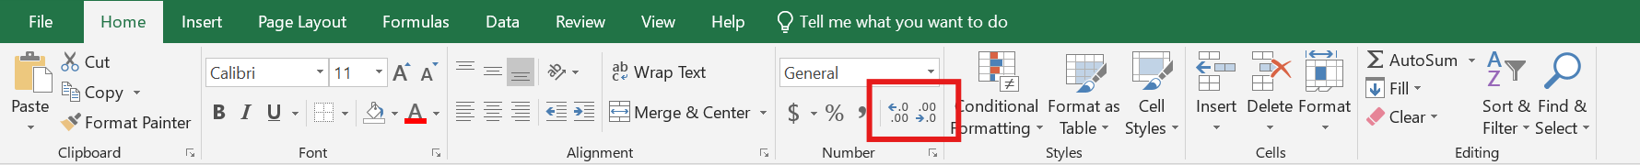

1. Graphs
   1. The easiest way to get the graphs we want is to copy the columns that we want to graph so that the data for the horizontal-axis is to the right of the data for the vertical-axis
      1. For instance, I copied the contents of column C and pasted the values into column L, then copied the contents of column G into column K
         1. Instead of “ctrl+V” right click and select the “paste-values” button

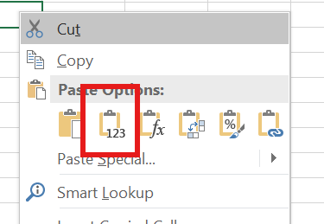

* 1. Highlight all 20 cells that you want to use as data
  2. Within the ribbon go to Insert>charts> scatter and pick the option with no lines and only points

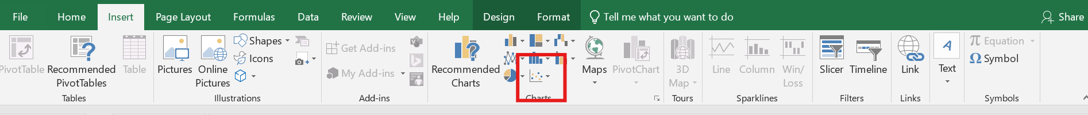

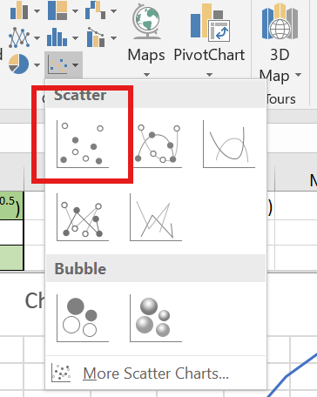

* 1. Once the chart is present fix the chart title and add axis titles (with all 3 parts from the first lab) (additionally for parts C and D add a trendline from the chart features menu)

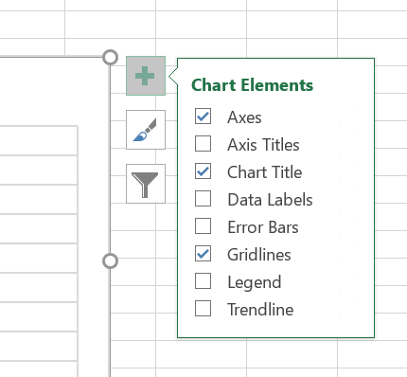

* 1. Click the triangle next to the Trendline select “additional options” to find the check box for adding a line equation
  2. With that sidebar still open click one of the numbers that make up the scale on your horizontal-axis, then navigate as shown below to adjust the max and min values so that your data takes up most of the chart, then repeat for the vertical-axis  
     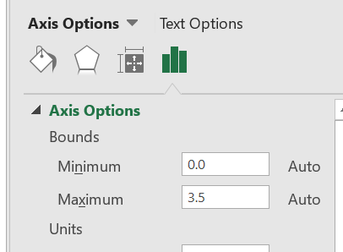
  3. Move the line equation to an area of your chart that is plain whitespace, then round the numbers to the correct sig figs and add units to both the slope (the part next to the ‘x’ and the y-intercept)